PSHE (Personal, Social, Health, Education) Policy

Reviewed: January 2022
Next Review due: January 2024
Reviewed by: C. Dorricott-Juniper

Policy Context and Rationale
The policy covers our school’s approach to Personal, Social, Health Education (PSHE). It was produced by Cassandra Dorricott Juniper, in consultation with the Headmaster and the Deputy Head.

(Personal, Social, Health, Education) Policy

Reviewed: January 2022
Next Review due: January 2024
Reviewed by: C. Dorricott-Juniper

Policy Context and Rationale
The policy covers our school’s approach to Personal, Social, Health Education (PSHE). It was produced by Cassandra Dorricott Juniper, in consultation with the Headmaster and the Deputy Head.

Contents
1 Policy context and rationale 2
2 Statutory requirements 2
3 Entitlement and equality of opportunities 3
4 Creating a safe and supportive learning environment 3
5 Intended outcomes 4
6 Teaching and learning 4
7 What we teach 4
8 How we teach it 5
9 Roles and responsibilities 5
10 How we promote PSHE, RSE, SMSC values around the school 6
11 Fundamental British values and SMSC 7
12 How Windlesham promotes the fundamental British values 8
13 Involving parents and carers 9
14 Links with other policies 9
Appendices

Appendix 1: School values and ethos displayed in each classroom

Appendix 2: Housepoint system

Appendix 3: Thankful wall

Appendix 4: Evidence of PSHE around the school

Appendix 5: PSHE trip

Appendix 6: Mindfulness

Appendix 7: Pupil reflection sheet

Appendix 8: How Windlesham School demonstrates British values

Appendix 9: Example assembly rota

Appendix 10: Twinkl assembly plan

Appendix 11: Long term overview of PSHE across the school

Appendix 12: PSHE Planning format showing how fundamental British values and SMSC values are covered in each lesson

Appendix 13: Poster promoting fundamental British values and SMSC values displayed in each classroom in the school

Appendix 14: Display promoting diversity and ways children have explored and learnt about diversity and inclusion through their lessons

Policy context and rationale
The policy covers our school’s approach to Personal, Social, Health Education (PSHE). It was produced by Cassandra Dorricott Juniper, PSHE Co-ordinator, in consultation with the Headmaster and the Deputy Head.
Our PSHE education programme is underpinned by the school values, enabling children to achieve the school vision which is “to promote joy in learning, pride in achievement and respect for others.” Windlesham School uses the teaching of PSHE as a key medium to help children develop into confident, respectful individuals. The syllabus and delivery methods of this subject aim to help children become law-abiding members of society empowered to voice their beliefs while remaining respectful and tolerant of others. The Relationships, Health and Sex Education (RSE) curriculum is delivered alongside PSHE. See here for the RSE policy.

Our warm, caring and friendly school aims to give children a sense of belonging, community and respect for others. Our broad and balanced curriculum, experienced staff and small classes are designed to promote an education tailored to individual needs, encouraging children to develop their particular talents and abilities. We aim to lay strong foundations for each child’s future, helping them to develop confidence, a sense of self and potential. We aim to instill in them a love of learning and exploration, encouraging effort and enthusiasm.
PSHE lessons are planned and timetabled each week, taught from Reception to Year 6. At Windlesham School, we use the Young Citizens scheme to implement PSHE. Young Citizens significantly contributes to the school’s safeguarding and equality duties, the government’s British values agenda and the Spiritual, Moral, Social, Cultural (SMSC) development opportunities provided for our children.

Statutory requirements
Under section 78 of the Education Act 2002 and the Academies Act 2010 a PSHE curriculum must:
- promote the spiritual, moral, cultural, mental and physical development of pupils at the school and of society.
- prepare pupils at the school for the opportunities, responsibilities and experiences of later life.
All schools must provide a curriculum that is broadly based, balanced and meets the needs of all pupils. From “The Relationships Education, Relationships and Sex Education and Health Education (England) Regulations 2019, made under sections 34 and 35 of the Children and Social Work Act 2017 we know that; PSHE is compulsory in independent schools and RSE is compulsory in all primary and secondary school from September 2020.
Schools also have duties in relation to promoting pupil wellbeing and pupil safeguarding (Children Act 2004) and community cohesion (Education Act 2006). Paragraph 41 of statutory guidance on Keeping Children Safe in Education, the Department for Education states that “schools should consider how children may be taught about safeguarding, including online, through teaching and learning opportunities. This may include covering relevant issues through PSHE.”
Through our delivery of weekly PSHE and RSE lessons we significantly contribute to the school’s safeguarding and equality duties, the Government’s British Values agenda and the SMSC development opportunities provided for our children.

Entitlement and equality of opportunities
The Independent School Guidance, states that: “The requirement is that the PSHE curriculum must be designed to encourage respect for other people, with particular regard to the protected characteristics set out in the Equality Act 2010.” At Windlesham we are respectful of all protected characteristics under the Equality Act 2010. Protected characteristics are age, disability, gender reassignment, race, religion or belief, sex, sexual orientation, marriage and civil partnership and pregnancy and maternity. We promote the needs and interests of all pupils, irrespective of gender, culture, ability or personal circumstance by ensuring the curriculum and learning is tailored for every individual child. We recognise the right for all pupils to have access to PSHE education learning which meets their needs, ensuring that lessons are SEND inclusive through differentiation of work and access to lessons and objectives suitable for their ability and maturity, as well as their understanding. Moreover, teachers will be mindful of the SEND Code of Practice 2014 when planning for this subject. We will use a scheme of work which best suits our children, decided through consultation with staff, the PSHE Co-ordinator and the head teacher.
Teaching will take into account the age, ability, readiness, the status of vulnerable and cultural backgrounds of children (and those with English as a second language) to ensure that all can fully access PSHE education provision. We expect our pupils to consider others’ needs by following the school’s vision and values of Respect, reminding them of this and promoting the correct and sensitive behaviour. We will use PSHE education as a way to address diversity issues and to ensure equality for all.

Creating a safe and supportive learning environment
This policy is informed by the school’s Safeguarding and Child Protection Policy . A safe and supportive learning environment will be created by both teachers and students agreeing to ground rules before commencing the PSHE lessons. Some examples of ground rules are:
- We will be respectful and sensitive of one other.
- We will listen to one another.
- We will be open to other’s opinions.
- We will be kind to one another.
Teachers are made aware by the Designated Safeguarding Lead of any children on the vulnerable child list. Teachers are aware that effective PSHE may lead to a disclosure of a child protection issue. All members of staff who deliver any of our PSHE programme, have statutory training around safeguarding children and are all aware of our school’s Safeguarding Policy and procedures in the case of a disclosure or suspicion of a safeguarding concern. Teachers will follow this safeguarding procedure set out in the Safeguarding Policy. Teachers will consult with the Designated Safeguarding Lead and in their absence, the Deputy Safeguarding Lead.

Intended outcomes
Active engagement in learning, rather than passively receiving information, is most effective in teaching PSHE education. Pupils are given opportunities to consider and clarify their values and beliefs and to rehearse and develop enquiry and interpersonal skills. This is achieved by providing them with a comprehensive, balanced and relevant body of factual information to inform their present and future choices.
Through the study of PSHE our pupils will:
- develop the skills and strategies needed to live healthy, safe, fulfilling lives; including in their relationships
- be encouraged to respect others’ rights to their own beliefs, values and opinions
- develop effective relationships
- assume greater personal responsibility for their personal safety, including online
- be introduced to a wider world and enable them to make an active contribution to their communities
- understand that there are basic human rights shared by all peoples and all societies and that children have their own special rights set out in the United Nations Declaration of the Rights of the Child

Teaching and learning

Principles and methodology
PSHE education needs to consider pupils’ starting points. Pupils will bring differing levels of knowledge and understanding to any issue explored through the PSHE education. Often this prior learning is more complex than we might assume. Teachers are encouraged to start each topic in PSHE with a discussion, allowing teachers to gauge pupils’ prior knowledge.

Planning
Please see Appendix 12 for a PSHE lesson planning template.

What we teach
To ensure progression through the year groups, we use Young Citizens as our main scheme of work. The teacher created content engages children and facilitates the delivery of a broad, balanced and relevant curriculum. We are also subscribed to Twinkl and TES to find resources to help teach PSHE.
Young Citizens supports Key Stage 1 and 2 teachers to ensure coverage of:
- SMSC learning including the teaching of fundamental British values
- Personal, Social, Health and Citizenship Education (PSHCE) including Relationships Education
- Values and Character Education
- Child-led social action and active citizenship project.
Young Citizens is used to plan our lessons and tailor activities to the needs of our children. See Appendix 11 for the long-term overview of PSHE in the school.

How we teach it
All pupils are expected to engage fully in PSHE and RSE and, when discussing issues related to PSHE, treat others with respect and sensitivity.

Use of mindfulness to support PSHE
As part of our delivery of PSHE we have implemented mindfulness throughout the school, we have an annual mindfulness presentation for parents, run mindfulness and well-being lunchtime clubs and use mindfulness within our assembles. Each classroom also has a mindfulness toolkit to remind teachers of some mindful activities such as; breathing exercises, meditation, yoga and meditation prompts (see Appendix 6).

Regularity
PSHE lessons are taught weekly by the class teachers from Reception to Year 4, and by different teachers in Years 5-6.

Personal Views
Different perspectives are encouraged, and children are taught to try to understand the views of others even when they differ significantly from their own. In line with the professional standards for all teachers, PSHE teachers should not share their personal beliefs, remaining objective and ensuring that teachers’ attitudes do not influence the content or the delivery of the curriculum.

Assessment
As part of our assessment of PSHE and RSE, we have introduced a pupil reflection sheet. See Appendix 7 for an example.
Progress in PSHE is delivered to parents through yearly reports. The teachers write a comment about the child’s learning in these lessons and their engagement. Moreover, parents are encouraged to email teachers through info@windleshamschool.co.uk if they have any queries about PSHE and RSE.

Roles and responsibilities

The teaching staff
Staff are responsible for:
- delivering PSHE in a sensitive way
- modelling positive attitudes to PSHE
- monitoring progress
- responding to the needs of individual pupils

PSHE Co-ordinator

The PSHE Co-ordinator, Cassandra Dorricott Juniper, is responsible for monitoring arrangements. The delivery of PSHE and RSE is monitored through:
- termly Learning walks
- termly reflection by teachers
- CPD sessions focused on sharing good practice
- book scrutiny
- a subject development plan

The Governing Board
The governing board will approve the PSHE and RSE policy. The governing board will hold the headteacher to account for the implementation of this policy.

The Headteacher
The headteacher is responsible for ensuring that PSHE is coordinated, taught and updated in accordance with regulations and that similarly, we meet the statutory requirements for RSE.

How we promote PSHE, RSE, SMSC values around the school
Across the whole school, PSHE is dovetailed into many aspects of the school timetable and curriculum, for example in assemblies, visitors, special events and charity days. It is not only taught in discrete lessons. Our ethos is displayed in each classroom and regularly referred to within the classroom (Appendix 1).

In addition, we reinforce values taught through PSHE and SMSC in the way we reward good behaviour; in part using our housepoint system (see Appendix 2). Children are rewarded with a housepoint for earnest displays of any of the following school values;
- listening well
- being fair, kind and honest
- caring for each other and the wider school
- being respectful
- working hard and trying my best.
Each classroom has a Thankfulness display, and throughout the year children and staff regularly write something they are thankful for (see Appendix 3). There are displays dedicated to PSHE around the school, ensuring that this subject is prominent and celebrated by students and staff alike, ensuring it is a core feature of our school. (See Appendix 4). School trips form an important part of our PSHE delivery. In fact, Year 3 is the first year group to introduce a PSHE-specific educational outing. Year 3 attend GoApe where children learn about teamwork, resilience and managing their emotions. See Appendix 5 for some children's reflections on this PSHE trip. Children in Year 3-6 take part in a residential trip where children will spend a night away as a group and take part in different games to develop their teamwork skills, their resilience and ability to collaborate with people who may be different to themselves. The duration of their stay increases with each year group such that Year 6 will stay away for 4 nights. The Year 6 residential trip is in France during the Summer term (unless pandemic guidance prohibits this trip). This exposes children to a different culture and generates a discussion about celebrating differences.

Fundamental British values and SMSC
Schools have an obligation under section 78 of the Education Act (2002) to offer a broad and balanced curriculum and “to promote the spiritual, moral, cultural, mental and physical development of pupils at the school and of society.” This guidance relates specifically to the requirements to “actively promote fundamental British values in schools and explains how this can be met through the general requirement. It is expected that pupils should understand that while different people may hold different views about what is ‘right’ and ‘wrong’, all people living in England are subject to its law.” At Windlesham, our ethos and teaching encourage respect for English civil and criminal law.
The Independent School Standards Guidance for independent schools April 2019 states that “there are requirements elsewhere in the standards for pupils to be taught about religions and belief systems in order to engender respect for other people” In line with this, we teach Religious Studies to children in nursery to year 6 to ensure all children understand that people around the world hold different beliefs and ensure that through this knowledge, children are respectful of beliefs different to their own. Schools should promote fundamental British values and demonstrate how they are meeting the requirements of section 78 of the Education Act 2002.

The fundamental British values are:
- democracy
- the rule of law
- individual liberty
- mutual respect
- tolerance of those of different faiths and beliefs

Evidence of our promotion of Fundamental British Values is most apparent in our planning template, used by all main school teachers (see Appendix 12 for an example of this) and the poster featured in every classroom promoting these (Appendix 13).

How Windlesham promotes the fundamental British values
Please refer to Appendix 8
- Democracy
All children contribute to the class rules for their classes at the beginning of the year. Children have many opportunities for their voices to be heard. We have a school council which meets regularly to discuss issues raised in class council meetings. The council member for each class is voted in by their class. Children have opportunities throughout the year to put forward their ideas about how to improve our school, we have boxes around the school where children can anonymously write down their opinions, which most recently included what playground equipment they would like.

- The Rule of Law
The importance of Laws, whether they be those that govern the class, the school, or the country, are consistently reinforced throughout regular school days, as well as when dealing with behaviour and through school assemblies. Pupils are taught the value and reasons behind laws, that they govern and protect us, the responsibilities that this involves and the consequences when laws are broken. Visits from authorities such as the police and fire service help reinforce this message.

- Individual liberty
Within school, pupils are actively encouraged to make choices, knowing that they are in a safe and supportive environment. As a school we educate and provide boundaries for young pupils to form opinions and make choices safely, through provision of a respectful environment. Pupils are encouraged to know, understand and exercise their rights and personal freedoms and are advised how to exercise these safely, for example through our E-Safety and PSHE lessons. Pupils are given the freedom to make choices in a variety of contexts; through their choice of a learning challenge, how they record their learning, which extra-curricular clubs they participate in and which grid homework tasks they commit to completing.

- Mutual Respect
Mutual respect is at the heart of our values and highlighted within our ethos. Children learn that their behaviours have an effect on their own rights and those of others. All members of the school community treat each other with respect. Through our reward system, awarding housepoints, a child can receive a housepoint for ‘Being Respectful’, which is a key feature of SMSC.

- Tolerance of those of different faiths and beliefs
Windlesham places a great emphasis on promoting diversity. Assemblies are regularly planned to address this theme either directly or through the inclusion of stories and celebrations from a variety of faiths and cultures. We have a permanent dedicated display promoting diversity and the ways children have explored and learnt about diversity and inclusion through their lessons (Appendix 14). Windlesham School celebrates diversity in all subjects. It is particularly evident in the topics addressed in the RSE, PSHE and Humanities curriculum. As a whole school we celebrate Black History month. We reach out to the community to engage visitors from a range of racial, cultural and professional backgrounds. For example, in Year 4 children have a whole topic dedicated to learning about the culture and people from Africa, which includes a workshop on African drums. In Year 5, we have a visitor from the Sikh community and in Year 3 we have a visitor from the Hindu community. In addition, we have recently appointed a Diversity and Inclusion Coordinator to ensure even greater promotion of both these aspects of our provision.

The purpose of SMSC, from the Independent School Standards Guidance is “to ensure that pupils’ development in non-academic terms will enable them to play a confident, informed role in society, have a fully developed value system, and be able to interact with other people in a positive way.” We ingrain these traits within our ethos at our school and are integral to our reward system through housepoints.

As well as actively promoting British values, we would actively challenge pupils, staff or
parents expressing opinions contrary to fundamental British values, including ‘extremist’ views.
Within the Independent School Standards Guidance there are some examples of different actions that schools could take in order to demonstrate the Government’s British Values agenda and the SMSC. Please see Appendix 8 for how Windlesham demonstrates this.

The Government’s British Values agenda and the SMSC is taught through PSHE and RSE lessons, reinforced in our ethos and reward system and shared through whole school and key stage specific assemblies. Refer to Appendix 9 for an example schedule of assembly rotas and the topics discussed. Moreover, in order to ensure adequate coverage of SMSC we use the Twinkl term planner for assemblies (see Appendix 10).

Involving parents and carers
Working in partnership with parents and carers and with the wider school community is an essential element of PSHE. We seek to keep parents informed through our newsletters and parents’ evenings. Parents are encouraged to attend information workshops addressing different topics such as internet safety and anti-bullying.

Links with other policies
This policy links to the following policies and procedures:
- RSE Policy
- Safeguarding policy
- Online Safety policy
- Anti-bullying policy
- Behaviour policy
- E- safety policy

This policy will be reviewed by the PSHE Coordinator every two years in collaboration with the Safeguarding Lead and Headteacher.

Appendix 1: School Values and ethos displayed in each classroom
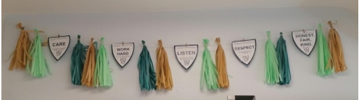

Appendix 2: Housepoint system
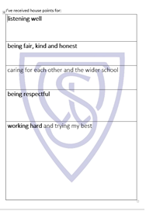
At the start of each term, an A5 log sheet incorporating the school values is inserted into the pupil’s diaries– 5 separate sections headed ‘I’ve received house points for..’ Teachers use the 10mm round black stamp to symbolize housepoints in the appropriate section and neatly date and initial the stamp to facilitate a quick count up each week. Each class will have their own stamp for teachers to use. PE/swimming can either use their own staff or ask/email form staff to allocate HP once back in the form room.
Collection: Class staff will count up the weekly accrued totals and enter them into the newly tweaked Class House Point Tracker ready for the House Captains to collect by visiting form rooms on a Wednesday/Thursday. House point class totals are then entered into a spreadsheet by the House Captains and are reported on weekly in Monday SMT Assemblies.
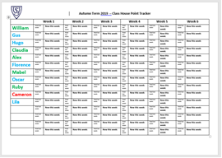
Tiered Achievements: Pupils individual progress is recognised by awarding certificates:
Bronze (15), Silver (30), Gold (45) , Platinum (60) , Diamond (75)
With each certificate a Golden Ticket will be received when pupils achieve each tier and will be entered into a termly draw and all totals are reset.
Postcards: Postcards will be posted home when a pupil achieves the Gold, Platinum and Diamond levels. Lower School/Upper School co-ordinators liaise with office staff.

Appendix 3: Thankful wall
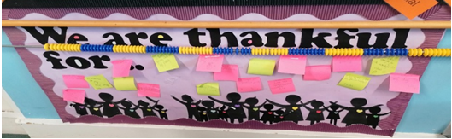

Appendix 4: Evidence of PSHE around the school

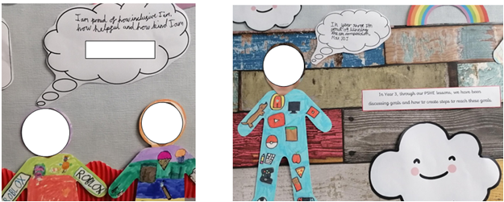

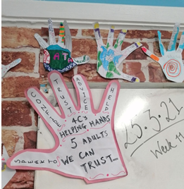
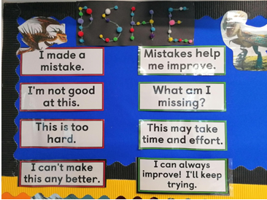

Appendix 5: PSHE trip

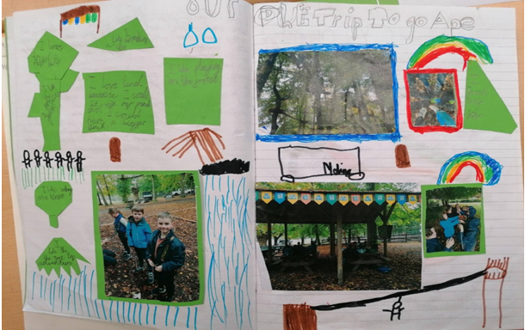

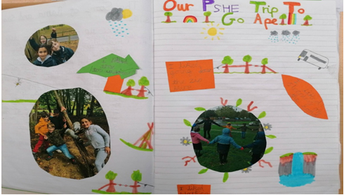

Appendix 6: Mindfulness
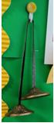
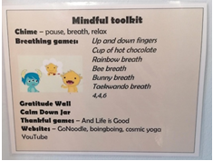

Appendix 7: Pupil reflection sheet
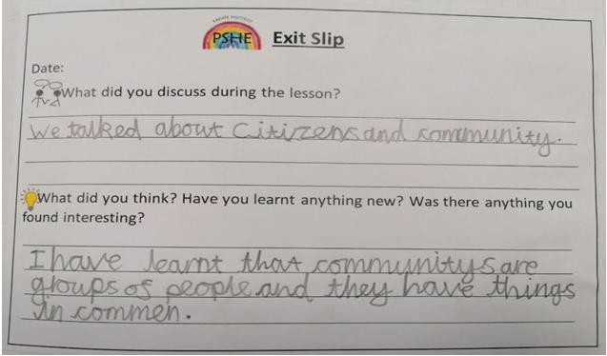

Appendix 8: How Windlesham School demonstrates British values
Different actions that schools could take p.19 Independent School Standards Guidance | How Windlesham demonstrates this.
including in suitable parts of the curriculum, as appropriate for the age of pupils, material on the strengths, advantages and disadvantages of democracy, and how democracy and the law works in the UK and other democracies, in contrast to other forms of government | - We have a school council system, where children vote for their class representative.  - We also have Head Pupils, where children write a speech and deliver it to the school in order to persuade people to vote for them. Each child and adult in the school votes for their choice via a ballot system.  - We teach Democracy and how the Law works in PSHE lessons.
ensuring that all pupils within the school have a voice that is listened to, and demonstrate how democracy works by actively promoting democratic processes such as a school council whose members are voted for by pupils | - Each child votes for head girl and head boy.  - Each child within a class, votes for their school councillor.  - All the children contribute to the drawing up of class rules at the beginning of the year.  - Children have many opportunities for their voices to be heard. We have a school council which meets regularly to discuss issues raised in class council meetings.  - Children have opportunities to put forward their views about the school. Most recently, using a ballot box to recommend new playground equipment for the school.
using opportunities such as general or local elections to hold mock elections to promote the fundamental British values, and provide pupils with the opportunity to learn how to argue and defend points of view | - Head pupils apply for their positions, make a speech to persuade each member of Windlesham school and afterwards a ballot system is used where each person votes for their preferred candidates. Assemblies and school mini elections have also reinforced local and national events.
enabling pupils to encounter people of different faith backgrounds | - Weekly Religious Studies lessons, children are encouraged to discuss their faith openly and share their beliefs with the class. Humanities trips to different religious faith backgrounds, in Year 5&6.
using teaching resources from a wide variety of sources to help pupils understand a range of faiths | - We deliver weekly Religious Studies lessons which teach children about the different faiths in our community. Cross curricular links are made in Humanities and whole school assemblies cover key dates and celebrations in a range of faiths. We also have visitors that come in to talk to children about their particular faith. In the past we have had visitors discussing Hinduism, Judaism and Sikhism and school trips visiting a local mosque and museums of interest.  Moreover, we offer a programme of assemblies focused on connecting with the community. This has featured a range of parents or guests who are able to share unique experiences, backgrounds and interests.
considering the role of extra-curricular activity, including any organised directly by pupils, in promoting the fundamental British values. | At Windlesham we have many clubs on offer that promote the fundamental British values.  In Spanish club - children learn about the culture of Spain and a respect for a different language.  In Magazine club- Children exercise their individual liberty by writing their views in a school magazine published each term.  Creative dance- Children learn to appreciate and show respect and tolerance of others by learning different traditional dances from around the world.

Appendix 9: Example assembly rota
Spring TERM | Monday | Friday- Merits & Housepoints
 | WS | WS- Celebration
04/01/2021 | John | Mel
11/01/2021 | Naomi | Gaynor
18/01/2021 | Martin Luther King day- Sinead | Orla
25/01/2021 | Burns Night- John | Lisa
01/02/2021 | National Story telling Week- Katherine | Rosa parks day (4th Feb)- Cassie
08/02/2021 | Internet Safety Week- Cassie | Inset
HALF TERM
22/02/2021 | Random acts of kindness week- John | Liz
01/03/2021 | World Book Day (4th March)- Katherine | Elenie
08/03/2021 | Science Week- Trish | World Maths Day- Aisling
15/03/2021 | St Patricks day- Naomi | Mel
22/03/2021 | Poetry Day- Katherine | John
End of term

Appendix 10: Twinkl assembly plan

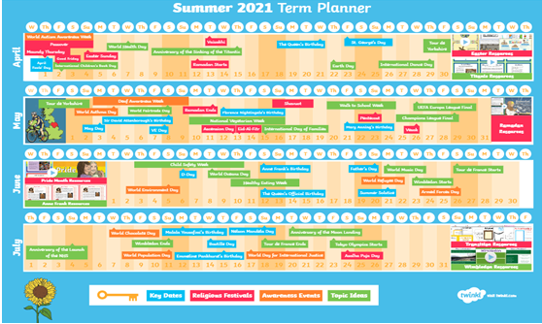

Appendix 11: Long term overview of PSHE across the school.
Please see the RSE Policy for the Sex Education Curriculum content. Summer term is dedicated to RSE, See RSE policy for this.
 | Year 1 | Year 2 | Year 3 | Year 4 | Year 5 | Year 6
Autumn 1 | Class rules. 3c  Learning Styles.  Friendship focus unique to class.  Meet the GoGivers (How to make new friends) 2a,2b,2c  Rules. | Class rules. 3c  Learning Styles.  Friendship focus unique to class. 2c  Resilience - bouncing back. | Class rules. 3c  Learning Styles.  Friendship focus unique to class. 2c  Peer pressure & stereotypes 3g,3f | Class rules. 3c  Learning Styles.  Friendship focus unique to class 2c.  Children's Rights. 3e  GOGIVERS: Our Class; Right to education; Mediation and resolving conflict | Class rules. 3c  Learning Styles.  Friendship focus unique to class. 2c  Nelson Mandela.  Sustainable Development. | Class rules. 3c  Learning Styles.  Friendship focus unique to class.  Rights and Responsibilities.
Autumn 2 | Anti-Bullying - The Selfish Hen. 3f  Taking Responsibility (Caring for Pets). 3b  Caring for our Community. 3b,3e  Taking Responsibility. | Anti-Bullying – 3f  Law - Anna's Monster Lies  The power of giving  How families look different around the world and in the community. Discuss how families are different around the world ie: adopting, same sex parents. 1c | Anti-Bullying -3f  Each person’s body belong to them linked to self respect. 5c  IPollution: Expedition to Planet Blueball | Anti-Bullying-3f  importance of permission seeking 3h  How to ask for advice or help, where to get advice from. 5h/2e  Safe in Cyber Space; Inspiring stories of young fundraisers 4c | Anti-Bullying, different types of bullying including cyberbullying & bystanders  Magna Carta.  Respecting all our differences – homophobia- relate to marriage and discuss same sex couples. . 1c | Anti-Bullying 3f  How to ask for advice or help, where to get advice from. 5h/2e  CITIZENSHIP AND THE WIDER WORLD & BEING PART OF A SCHOOL COMMUNITY  How to recognise if family relationships are making them feel unhappy or unsafe and how to seek advice. 1f
Spring 1 | Internet Safety. 4c  Litter, pollution. 3b  Pedestrian training. | Internet Safety. 4c  Friendships - More than just one friend (different points of view.) 2d,2b  Family relationships- People Who Are Special To Me. 1a,1b | Internet Safety. 4c+ How to recognise and report feeling of being unsafe online. 5e  Community - Schools focus.  Community/global citizen - GoGivers Park. 3b | Internet Safety. 4c,4d  GOGIVERS: Fairtrade;  Debates/different opinions - (Conscience Corridor, For and Against.); Climate change | Internet Safety (Keeping Safe in Cyberspace.) 4c,4d  Know how information and data is shared and used online. 4e  Heroes - Martin Luther King. Mary Seacole & Florence Nightingale. | Internet Safety-USING TECHNOLOGY FOR GOOD 4c,4d  DEMOCRACY - PART 1 DEMOCRACY - PART 2  DEMOCRACY - PART 3  Gandhi (working for peace).
Spring 2 | Managing Anger. 5a  Characteristic of healthy family life- protections and care for chn and importance of spending time together. Challenge nuclear family stereotype (ie: single parents, same sex parents). 1b | PLASTIC POLLUTION  SAVING ENERGY  How to recognise who to trust, how to judge if a friendship is making them unhappy & how to seek advice or support if needed. 2e | Environment - (The Earth in Our Hands.) (What kind of Farming).  Refugees | GOGIVERS:  Equal Opportunities. 3a  Gift of Sight. | Diversity3a - identities. Belonging to groups.  Brexit. International Trade after Brexit.  Jealousy.  Science: Sexual and asexual reproduction of plants. | Handling Stress.  WHAT IS AN INFECTIOUS DISEASE?PREVENTING INFECTIOUS DISEASE  Stable, caring relationships=heart of happy families, important for children’s security as they grow up. Challenge stereotypical family units, discuss same sex relationships and different ways of conceptions ie: IVF, surrogacy. 1d  Marriage= legally recognised commitment to two people. 1e
Summer 1
Summer 2

Appendix 12: PSHE Planning format showing how fundamental British values and SMSC values are covered in each lesson.
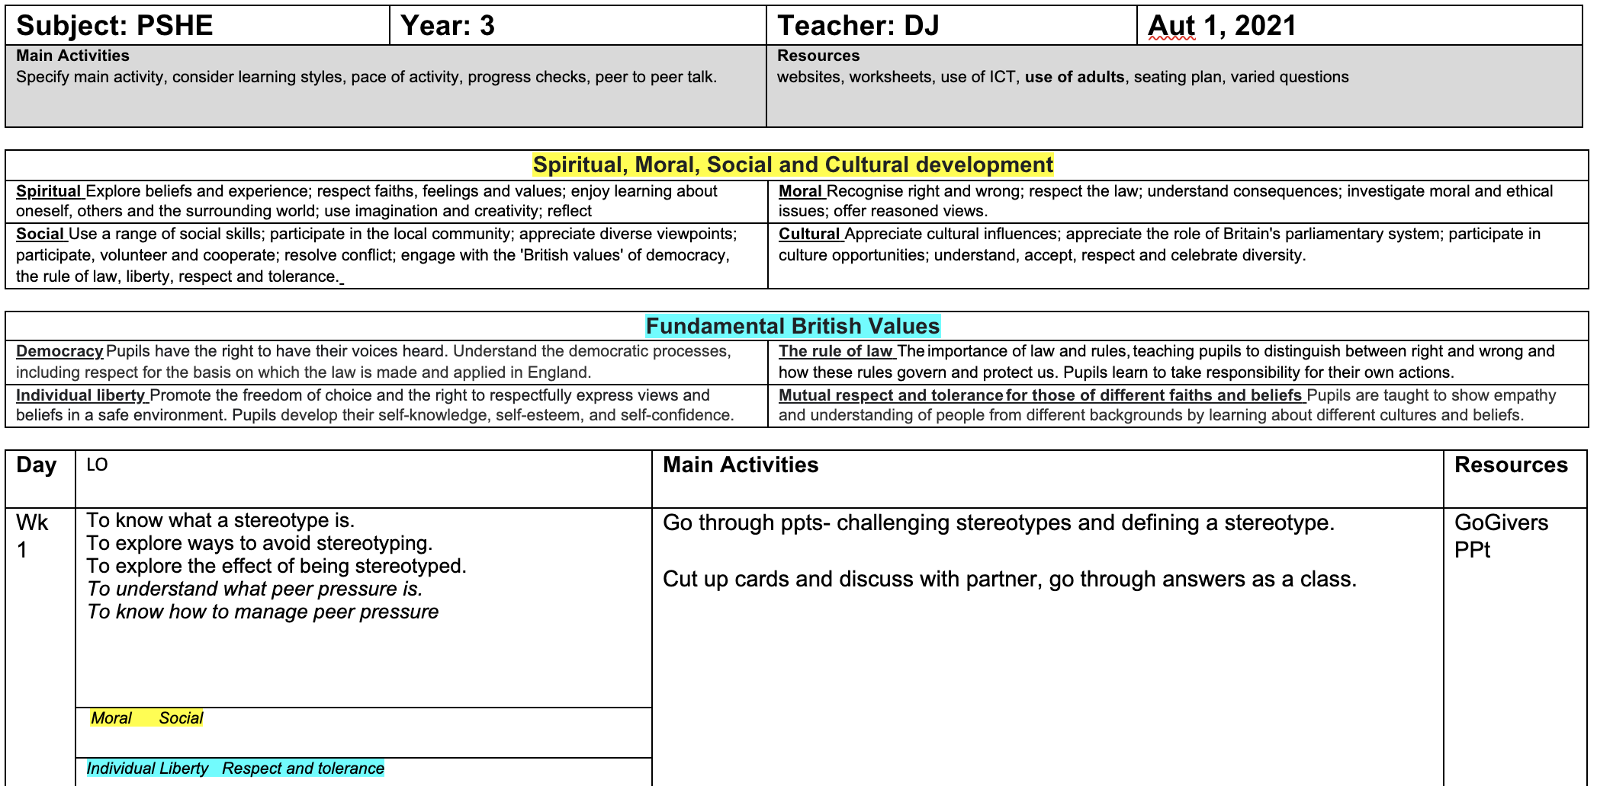

Appendix 13: Poster promoting fundamental British values and SMSC values displayed in each classroom in the school
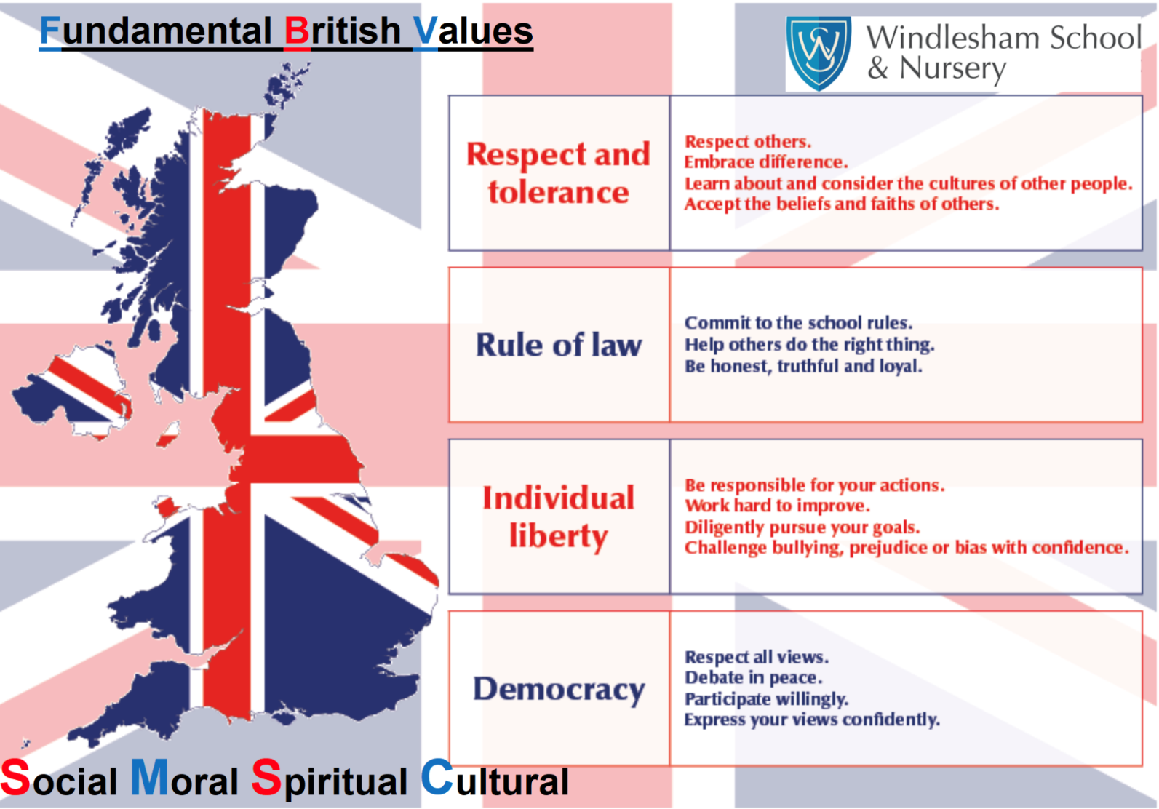

Appendix 14: Display promoting diversity and ways children have explored and learnt about diversity and inclusion through their lessons

